**Make an E-commerce Website for Sporty Shoes**

**Document contains:**

* Project and developer details
* Sprints planned and the tasks achieved in them
* Algorithms and flowcharts of the application
* List of core concepts used
* Links to the GitHub repository to verify the project completion
* Conclusions

**Project and developer details**

**Project objective:**

As a Full Stack Developer, complete the features of the application by planning the development and pushing the source code to the GitHub repository.

**Background of the problem statement:**

Sporty Shoes is a company that manufactures and sells sports shoes. They have a walk-in store, and now, they wish to launch their e-commerce portal sportyshoes.com.

You’re asked to develop a prototype of the application. It will be then presented to the relevant stakeholders for budget approval. Your manager has set up a meeting where you’re asked to do the following:

Presenting the specification document which has the product’s capabilities, appearance, and user interactions

Setting up Git and GitHub account to store and track your enhancements of the prototype

Explaining the Java concepts used in the project

**Discussing the generic features of the product:**

There will be an admin to manage the website. An administrator login will be required to access the admin page.

**The admin should be able to change his password if he wants, he should be able to:**

Manage the products in the store including categorizing them

Browse the list of users who have signed up and be able to search users

See purchase reports filtered by date and category

**Developer Details**: S.V. SAI KUMAR

svsai97@gmail.com

**Sprints planned and the tasks achieved in them**

There are three sprints for this project

Sprint-1: Studied the Features of project and prepared the flow chart and created Git Repository.

Sprint-2: In Spring Boot created Jsp pages and written Controller ,repository, securityconfig, Dao, Pojo and All the features are being implemented.

Sprint-3: Final testing of website using different inputs and pushing it to GitHub.

Codes:

**Users.java**

package com.example.demo;

import javax.persistence.Column;

import javax.persistence.Entity;

import javax.persistence.GeneratedValue;

import javax.persistence.GenerationType;

import javax.persistence.Id;

import lombok.AllArgsConstructor;

import lombok.Data;

import lombok.NoArgsConstructor;

@Entity

@Data

@AllArgsConstructor

@NoArgsConstructor

public class users {

@Id

@GeneratedValue(strategy = GenerationType.IDENTITY)

private int userid;

private String username;

private String password;

private String role;

private Boolean enabled;

private String name;

private String useremail;

private String contactno;

private String adress;

private String pincode;

}

**usersDao**

package com.example.demo;

import java.util.List;

import java.util.Optional;

import org.springframework.beans.factory.annotation.Autowired;

import org.springframework.stereotype.Service;

@Service

public class usersDao {

@Autowired

usersrepositry repo;

public users insert(users u) {

return repo.save(u);

}

//retrieve

public List<users> getusers() {

return repo.findusers();

}

}

**usersrepositry**

package com.example.demo;

import java.util.List;

import org.springframework.data.jpa.repository.JpaRepository;

import org.springframework.data.jpa.repository.Query;

public interface usersrepositry extends JpaRepository<users,Integer> {

@Query("select users from users users where role='USER'")

public List<users> findusers();

}

**Product.java**

package com.example.demo;

import javax.persistence.Column;

import javax.persistence.Entity;

import javax.persistence.GeneratedValue;

import javax.persistence.GenerationType;

import javax.persistence.Id;

import lombok.AllArgsConstructor;

import lombok.Data;

import lombok.NoArgsConstructor;

@Entity

@Data

@AllArgsConstructor

@NoArgsConstructor

public class product {

@Id

private Long productid;

private String productcategory;

private String productname;

private String productprice;

private String productdescription;

}

**productDao.java**

package com.example.demo;

import java.util.List;

import java.util.Optional;

import org.springframework.beans.factory.annotation.Autowired;

import org.springframework.stereotype.Service;

@Service

public class productDao {

@Autowired

productrepositry repo;

public product insert(product p) {

return repo.save(p);

}

//retrieve

public List<product> getproduct() {

return repo.findAll();

}

public product delete(long id) {

repo.deleteById(id);

return null;

}

public List<product> getproductbycategory(String name) {

return repo.findproductbycategory(name);

}

}

**Productrepositry.java**

package com.example.demo;

import java.util.List;

import org.springframework.data.jpa.repository.JpaRepository;

import org.springframework.data.jpa.repository.Query;

public interface productrepositry extends JpaRepository<product,Long> {

@Query("select product from product product where productcategory=?1")

public List<product> findproductbycategory(String name);

}

**Cart.java**

package com.example.demo;

import java.util.Date;

import javax.persistence.Column;

import javax.persistence.Entity;

import javax.persistence.GeneratedValue;

import javax.persistence.GenerationType;

import javax.persistence.Id;

import javax.persistence.UniqueConstraint;

import org.springframework.format.annotation.DateTimeFormat;

import lombok.AllArgsConstructor;

import lombok.Data;

import lombok.NoArgsConstructor;

@Entity

@Data

@AllArgsConstructor

@NoArgsConstructor

public class cart {

@Id

@GeneratedValue

private long cartid;

private String username;

private Long productid;

private String productcategory;

private String productname;

private String productprice;

private String orderno;

@DateTimeFormat(pattern="dd-MM-yyyy")

private Date dateofpurchase;

private String payment;

}

**cartDao.java**

package com.example.demo;

import java.util.Date;

import java.util.List;

import org.springframework.beans.factory.annotation.Autowired;

import org.springframework.stereotype.Service;

@Service

public class cartDao {

@Autowired

cartrepositry repo;

public cart insert(cart c) {

return repo.save(c);

}

public cart deletebyid(long id) {

repo.deleteById(id);

return null;

}

public List<cart> getcartbyusername(String name) {

return repo.findcartbyusername(name);

}

public List<cart> getcartbypayment() {

return repo.findcartbypayment();

}

public void updatebyuser(Date Date,String orderno,String payment ,String username) {

repo.updatebyuser(Date, orderno, payment, username);

}

}

**Cartrepositry.java**

package com.example.demo;

import java.util.Date;

import java.util.List;

import org.springframework.data.jpa.repository.JpaRepository;

import org.springframework.data.jpa.repository.Modifying;

import org.springframework.data.jpa.repository.Query;

import org.springframework.transaction.annotation.Transactional;

public interface cartrepositry extends JpaRepository<cart,Long> {

@Query("select cart from cart cart where username=?1 and payment='notpaid'")

public List<cart> findcartbyusername(String name);

@Transactional

@Modifying

@Query("update cart set dateofpurchase=?1,orderno=?2,payment=?3 where username=?4 and payment='notpaid'")

public void updatebyuser(Date date,String orderno,String payment ,String username);

@Query("select cart from cart cart where payment='paid'")

public List<cart> findcartbypayment();

}

**mainController.java**

package com.example.demo;

import java.io.IOException;

import java.io.PrintWriter;

import java.text.ParseException;

import java.text.SimpleDateFormat;

import java.util.ArrayList;

import java.util.Date;

import java.util.List;

import java.util.Optional;

import javax.servlet.http.HttpServletRequest;

import javax.servlet.http.HttpServletResponse;

import org.springframework.beans.factory.annotation.Autowired;

import org.springframework.security.core.Authentication;

import org.springframework.security.core.context.SecurityContextHolder;

import org.springframework.stereotype.Controller;

import org.springframework.web.bind.annotation.GetMapping;

import org.springframework.web.bind.annotation.PutMapping;

import org.springframework.web.bind.annotation.RequestBody;

import org.springframework.web.bind.annotation.RequestMapping;

import org.springframework.web.bind.annotation.RequestParam;

import org.springframework.web.bind.annotation.ResponseBody;

import org.springframework.web.servlet.ModelAndView;

@Controller

@RequestMapping("/")

public class mainController {

@Autowired

usersDao udao;

@Autowired

productDao pdao;

@Autowired

cartDao cdao;

public String amount;

public String id;

@RequestMapping("/")

public ModelAndView displaydefaultpage(HttpServletRequest request,HttpServletResponse response)

{

ModelAndView mv=new ModelAndView();

mv.setViewName("home.jsp");

return mv;

}

@RequestMapping("/loginhome")

public ModelAndView adminhome(HttpServletRequest request,HttpServletResponse response)

{

ModelAndView mv=new ModelAndView();

Authentication authentication = SecurityContextHolder.getContext().getAuthentication();

String role=authentication.getAuthorities().stream().findAny().get().getAuthority();

System.out.println(role);

if (role.equals("ADMIN")) {

mv.setViewName("adminHome.jsp");

}

if (role.equals("USER")) {

mv.setViewName("userHome.jsp");

}

return mv;

}

@RequestMapping("/updatepassword")

public ModelAndView updatepassword(users u ,HttpServletRequest request,HttpServletResponse response) throws IOException {

ModelAndView mv=new ModelAndView();

u.setUserid(1);

u.setUsername("admin");

u.setEnabled(true);

u.setRole("ADMIN");

u.setPassword(request.getParameter("password"));

udao.insert(u);

mv.setViewName("updatesucesshome.jsp");

return mv;

}

@RequestMapping("/userRegistration")

public ModelAndView registeruserdetails(users u ,HttpServletRequest request,HttpServletResponse response) throws IOException {

ModelAndView mv=new ModelAndView();

u.setUsername(request.getParameter("username"));

u.setPassword(request.getParameter("password"));

u.setName(request.getParameter("name"));

u.setContactno(request.getParameter("contactno"));

u.setPincode(request.getParameter("pincode"));

u.setName(request.getParameter("useremail"));

u.setName(request.getParameter("adress"));

u.setEnabled(true);

u.setRole("USER");

udao.insert(u);

mv.setViewName("updatesucesshome.jsp");

return mv;

}

@RequestMapping("/listusers")

public ModelAndView getalluser(HttpServletRequest request,HttpServletResponse response) {

ModelAndView mv=new ModelAndView();

List<users> list=udao.getusers();

mv.setViewName("userlist.jsp");

mv.addObject("list", list);

return mv;

}

@RequestMapping("/searchuser")

public ModelAndView getuser(users u,HttpServletRequest request,HttpServletResponse response) {

ModelAndView mv=new ModelAndView();

List<users> list=udao.getusers();

mv.setViewName("userlistsearch.jsp");

mv.addObject("list", list);

u.setUsername(request.getParameter("username"));

return mv;

}

@RequestMapping("/addproduct")

public ModelAndView addproductdetails(product p ,HttpServletRequest request,HttpServletResponse response) throws IOException {

ModelAndView mv=new ModelAndView();

String pid=request.getParameter("productid");

if (pid=="") {

pid = "0";

}

Long id=Long.parseLong(pid);

String pcategory=request.getParameter("productcategory");

String pname=request.getParameter("productname");

String pprice=request.getParameter("productprice");

if (pprice=="") {

pprice= "0";

}

Double price=Double.parseDouble(pprice);

String pdesc=request.getParameter("productdescription");

if(id!=0 && pcategory!="" && pname!="" && price!=0 &&pdesc!="") {

p.setProductid(Long.parseLong(request.getParameter("productid")));

p.setProductcategory(request.getParameter("productcategory"));

p.setProductname(request.getParameter("productname"));

p.setProductprice(request.getParameter("productprice"));

p.setProductdescription(request.getParameter("productdescription"));

pdao.insert(p);

mv.setViewName("listproduct");

}

if(id==0 || pcategory=="" || pname=="" || price==0 || pdesc=="") {

mv.setViewName("addProduct.jsp");

}

return mv;

}

@RequestMapping("/updateproduct")

public ModelAndView updateproductdetails(product p ,HttpServletRequest request,HttpServletResponse response) throws IOException {

ModelAndView mv=new ModelAndView();

String pcategory=request.getParameter("productcategory");

String pname=request.getParameter("productname");

String pprice=request.getParameter("productprice");

if (pprice=="") {

pprice= "0";

}

Double price=Double.parseDouble(pprice);

String pdesc=request.getParameter("productdescription");

if( pcategory!="" && pname!="" && price!=0 &&pdesc!="") {

p.setProductid(Long.parseLong(request.getParameter("productid")));

p.setProductcategory(request.getParameter("productcategory"));

p.setProductname(request.getParameter("productname"));

p.setProductprice(request.getParameter("productprice"));

p.setProductdescription(request.getParameter("productdescription"));

pdao.insert(p);

mv.setViewName("listproduct");

}

if(pcategory=="" || pname=="" || price==0 || pdesc=="") {

mv.setViewName("updateProduct.jsp");

}

return mv;

}

@RequestMapping("/deleteproduct")

public ModelAndView deleteproductdetails(HttpServletRequest request,HttpServletResponse response) throws IOException {

ModelAndView mv=new ModelAndView();

long id =Long.parseLong(request.getParameter("productid"));

pdao.delete(id);

mv.setViewName("listproduct");

return mv;

}

@RequestMapping("/listproduct")

public ModelAndView getallproduct(HttpServletRequest request,HttpServletResponse response) {

ModelAndView mv=new ModelAndView();

List<product> list=pdao.getproduct();

mv.setViewName("productmodify.jsp");

mv.addObject("list", list);

return mv;

}

@RequestMapping("/purchasereport")

public ModelAndView showcartbypatment(cart c, HttpServletRequest request,HttpServletResponse response) {

ModelAndView mv=new ModelAndView();

List<cart> list=cdao.getcartbypayment();

mv.addObject("list", list);

mv.setViewName("purchaseReports.jsp");

return mv;

}

/////////////////////////

@RequestMapping("/productbycategory")

public ModelAndView getproductbycategory(HttpServletRequest request,HttpServletResponse response) {

ModelAndView mv=new ModelAndView();

List<product> list=pdao.getproductbycategory(request.getParameter("productcategory"));

mv.setViewName("productbyCategory.jsp");

mv.addObject("list", list);

return mv;

}

@RequestMapping("/addtocart")

public ModelAndView addcart(cart c, HttpServletRequest request,HttpServletResponse response) {

ModelAndView mv=new ModelAndView();

Authentication auth = SecurityContextHolder.getContext().getAuthentication();

String username = auth.getName();

Long productid=Long.parseLong(request.getParameter("productid"));

String productname=request.getParameter("productname");

String productPrice=request.getParameter("productprice");

String productcategory=request.getParameter("productcategory");

c.setUsername(username);

c.setProductid(productid);

c.setProductname(productname);

c.setProductcategory(productcategory);

c.setProductprice(productPrice);

c.setPayment("notpaid");

cdao.insert(c);

mv.setViewName("addcartsucess.jsp");

return mv;

}

@RequestMapping("/showCart")

public ModelAndView showcart(cart c, HttpServletRequest request,HttpServletResponse response) {

ModelAndView mv=new ModelAndView();

Authentication auth = SecurityContextHolder.getContext().getAuthentication();

String username = auth.getName();

List<cart> list=cdao.getcartbyusername( username);

mv.addObject("list", list);

mv.setViewName("showcart.jsp");

return mv;

}

@RequestMapping("/failpayment")

public ModelAndView showcart2(cart c, HttpServletRequest request,HttpServletResponse response) {

ModelAndView mv=new ModelAndView();

Authentication auth = SecurityContextHolder.getContext().getAuthentication();

String username = auth.getName();

List<cart> list=cdao.getcartbyusername( username);

mv.addObject("list", list);

mv.setViewName("failpayshowcart.jsp");

return mv;

}

@RequestMapping("/removefromcart")

public ModelAndView removefromcart(cart c, HttpServletRequest request,HttpServletResponse response) {

ModelAndView mv=new ModelAndView();

long id=Long.parseLong(request.getParameter("cartid"));

cdao.deletebyid(id);

mv.setViewName("showCart");

return mv;

}

@RequestMapping("/paymentcheck")

public ModelAndView paymentcheck( HttpServletRequest request,HttpServletResponse response) throws ParseException {

ModelAndView mv=new ModelAndView();

String cardnum=request.getParameter("cardno");

String month=request.getParameter("month");

String pswrd=request.getParameter("psd");

System.out.println("check");

if (cardnum=="") {

cardnum = "0";

}

Long cardno=Long.parseLong(cardnum);

if(cardno!=0 && month!="" && pswrd!="") {

amount=request.getParameter("amt");

id=request.getParameter("order");

mv.setViewName("paid.jsp");

Authentication auth = SecurityContextHolder.getContext().getAuthentication();

String username = auth.getName();

Date dNow = new Date( );

SimpleDateFormat ft =new SimpleDateFormat ("dd-MM-yyyy");

String dt1=ft.format(dNow);

Date date=new SimpleDateFormat("dd-MM-yyyy").parse(dt1);

String orderno=request.getParameter("order");

String payment="paid";

cdao.updatebyuser(date, orderno, payment,username);

}

else {

mv.setViewName("failpayment");

}

return mv;

}

}

**SecurityConfig.java**

package com.example.demo;

import javax.sql.DataSource;

import org.springframework.beans.factory.annotation.Autowired;

import org.springframework.context.annotation.Bean;

import org.springframework.security.config.annotation.authentication.builders.AuthenticationManagerBuilder;

import org.springframework.security.config.annotation.web.builders.HttpSecurity;

import org.springframework.security.config.annotation.web.configuration.EnableWebSecurity;

import org.springframework.security.config.annotation.web.configuration.WebSecurityConfigurerAdapter;

import org.springframework.security.crypto.password.NoOpPasswordEncoder;

import org.springframework.security.crypto.password.PasswordEncoder;

@EnableWebSecurity

public class SecurityConfig extends WebSecurityConfigurerAdapter {

@Autowired

DataSource dataSource;

@Override

protected void configure(AuthenticationManagerBuilder auth) throws Exception {

auth.jdbcAuthentication()

.dataSource(dataSource)

.usersByUsernameQuery("select username, password, enabled from users where username=?")

.authoritiesByUsernameQuery("select username, role from users where username=?");

}

@Bean

public PasswordEncoder getpassword() {

return NoOpPasswordEncoder.getInstance();

}

//authorize

@Override

protected void configure(HttpSecurity http) throws Exception {

http.authorizeRequests()

.antMatchers("/updatepassword").hasAuthority("ADMIN")

.antMatchers("/listusers").hasAuthority("ADMIN")

.antMatchers("/searchuser").hasAuthority("ADMIN")

.antMatchers("/addproduct").hasAuthority("ADMIN")

.antMatchers("/updateproduct").hasAuthority("ADMIN")

.antMatchers("/deleteproduct").hasAuthority("ADMIN")

.antMatchers("/listproduct").hasAuthority("ADMIN")

.antMatchers("/purchasereport").hasAuthority("ADMIN")

.antMatchers("/productbycategory").hasAuthority("USER")

.antMatchers("/addtocart").hasAuthority("USER")

.antMatchers("/showCart").hasAuthority("USER")

.antMatchers("/failpayment").hasAuthority("USER")

.antMatchers("/removefromcart").hasAuthority("USER")

.antMatchers("/paymentcheck").hasAuthority("USER")

.antMatchers("/loginhome").hasAnyAuthority("ADMIN","USER")

.antMatchers("/").permitAll()

.antMatchers("/userRegistration").permitAll()

.and().formLogin().defaultSuccessUrl("/loginhome")

.and().logout().logoutSuccessUrl("/");

}

}

**SportyShoesApplication.java**

package com.example.demo;

import org.springframework.boot.SpringApplication;

import org.springframework.boot.autoconfigure.SpringBootApplication;

@SpringBootApplication

public class SportyShoesApplication {

public static void main(String[] args) {

SpringApplication.run(SportyShoesApplication.class, args);

}

}

Jsp

Home.jsp

<%@ page language=*"java"* contentType=*"text/html; charset=ISO-8859-1"*

pageEncoding=*"ISO-8859-1"*%>

<!DOCTYPE html>

<html>

<head>

<meta charset=*"ISO-8859-1"*>

<title>Home</title>

</head>

<body style="background:*url(picer.jpg) no-repeat*;background-size:*90% auto*; ">

<div align=*"center"*>

<i><h1>SportyShoes</h1></i>

<h4 align=*"right"*> - devloped by S.V. SAI KUMAR</h4>

<br><br>

<h1>Welcome, Shop According to Your Sports</h1><br>

<b> <input style=font-size:*24px* type=*"button"* onclick="window.location.href='login';" value=*"Admin Signin"* /></b><br><br><br>

<b> <input style=font-size:*24px* type=*"button"* onclick="window.location.href='login';" value=*" User Signin "* /></b><br><br>

<h3><a href=*'userRegistration.jsp'* style="text-decoration: *none*">new here? Create Account</a></h3>

</form>

</div>

</body>

</html>

**userRegistration.jsp**

<%@ page language=*"java"* contentType=*"text/html; charset=ISO-8859-1"*

pageEncoding=*"ISO-8859-1"*%>

<!DOCTYPE html>

<html>

<head>

<meta charset=*"ISO-8859-1"*>

<title>Register</title>

</head>

<body style="background:*url(picer.jpg) no-repeat*;background-size:*90% auto*; ">

<div align=*"center"*>

<i><h1>SportyShoes</h1></i>

<h4 align=*"right"*> - devloped by S.V. SAI KUMAR</h4><br>

<br><br>

<h3>Enter Details</h3>

<form action=*"userRegistration"*><br>

<table>

<tr>

<td><b>Name</b></td>

<td><input type =*"text"* name=*"name"* ></td>

</tr>

<tr>

<td><b>Email</b></td>

<td><input type =*"email"* name=*"useremail"* ></td>

</tr>

<tr>

<td><b>Phone no</b></td>

<td><input type =*"number"* name=*"contactno"* ></td>

</tr>

<tr>

<td><b>Address</b></td>

<td><input type =*"text"* name=*"adress"* ></td>

</tr>

<tr>

<td><b>Pincode</b></td>

<td><input type =*"number"* name=*"pincode"* ></td>

</tr>

<tr>

<td><b>Username</b></td>

<td><input type =*"text"* name=*"username"* ></td>

</tr>

<tr>

<td><b>Password</b></td>

<td><input type =*"password"* name=*"password"* ></td>

</tr>

</table>

<br><input type =*"submit"* value=*"Register"*>

</form>

</div>

</body>

</html>

**adminHome.jsp**

<%@ page language=*"java"* contentType=*"text/html; charset=ISO-8859-1"*

pageEncoding=*"ISO-8859-1"*%>

<!DOCTYPE html>

<html>

<head>

<meta charset=*"ISO-8859-1"*>

<title>Admin Home</title>

</head>

<body style="background:*url(picer.jpg) no-repeat*;background-size:*90% auto*; ">

<div align=*"center"*>

<i><h1>SportyShoes</h1></i>

<h4 align=*"right"*> - devloped by S.V. SAI KUMAR</h4><br>

<h3 align=*"right"*><a href=*'logout'* style="text-decoration: *none*">Logout</a></h3>

<br><br>

<h1>Home</h1>

<h3><a href=*'changepassword.jsp'* style="text-decoration: *none*">Change Password</a></h3>

<h3><a href=*'listproduct'* style="text-decoration: *none*">Add, Delete or Update Products</a></h3>

<h3><a href=*'listusers'* style="text-decoration: *none*">List of Users</a></h3>

<h3><a href=*'purchasereport'* style="text-decoration: *none*">Purchase Reports</a></h3>

</div>

</body>

</html>

**Changepassword.jsp**

<%@ page language=*"java"* contentType=*"text/html; charset=UTF-8"*

pageEncoding=*"UTF-8"*%>

<!DOCTYPE html>

<html>

<head>

<meta charset=*"UTF-8"*>

<title>Change Password</title>

</head>

<body style="background:*url(picer.jpg) no-repeat*;background-size:*90% auto*; ">

<div align=*"center"*>

<i><h1>SportyShoes</h1></i>

<h4 align=*"right"*> - devloped by S.V. SAI KUMAR</h4><br>

<h3 align=*"right"*><a href=*'adminHome.jsp'* style="text-decoration: *none*">Home</a> &nbsp;&nbsp;&nbsp;&nbsp;&nbsp;<a href=*'logout'* style="text-decoration: *none*">Logout</a></h3>

<br><br>

<form action=*"updatepassword"* >

<b>Enter New password </b><input type =*"Password"* name=*"password"* ><br><br>

<input type=*"submit"* name=*"update"* value=*"Change Password"*>

</form>

</div>

</body>

</html>

**userlist.jsp**

<%@page import=*"com.example.demo.users"*%>

<%@page import=*"java.util.*"*%>

<%@ page import=*"com.example.*"*%>

<%@ page language=*"java"* contentType=*"text/html; charset=ISO-8859-1"*

pageEncoding=*"ISO-8859-1"*%>

<!DOCTYPE html>

<html>

<head>

<meta charset=*"ISO-8859-1"*>

<title>userlist</title>

</head>

<body style="background:*url(picer.jpg) no-repeat*;background-size:*90% auto*; ">

<%

List<users> list=(List<users>)request.getAttribute("list");

%>

<div align=*"center"*>

<i><h1>SportyShoes</h1></i>

<h4 align=*"right"*> - devloped by S.V. SAI KUMAR</h4><br>

<h3 align=*"right"*><a href=*'adminHome.jsp'* style="text-decoration: *none*">Home</a> &nbsp;&nbsp;&nbsp;&nbsp;&nbsp;<a href=*'logout'* style="text-decoration: *none*">Logout</a></h3>

<br><br>

<form action=*"searchuser"*>

<b>Search by Username </b><input type =*"text"* name=*"username"*>

<input type =*"submit"* name=*"ok"* value=*"Search"*>

</form>

<br><br>

<table border=*"1"* cellpadding =*"5"* cellspacing =*"5"*>

<tr><th>User Id</th><th>Name</th><th>UserName</th><th>Email</th><th>Address</th><th>Contact No</th><th>Pincode</th></tr>

<%**for**(users u:list){ %>

<tr><td><%=u.getUserid()%></td><td><%=u.getName() %></td><td><%=u.getUsername() %></td><td><%=u.getUseremail()%></td><td><%=u.getAdress()%></td><td><%=u.getContactno()%></td><td><%=u.getPincode()%></td></tr>

<%}%>

</table>

</div>

</body>

</html>

**userlistSearch.jsp**

<%@page import=*"com.example.demo.*"*%>

<%@page import=*"java.util.*"*%>

<%@ page import=*"com.example.*"*%>

<%@ page language=*"java"* contentType=*"text/html; charset=ISO-8859-1"*

pageEncoding=*"ISO-8859-1"*%>

<!DOCTYPE html>

<html>

<head>

<meta charset=*"ISO-8859-1"*>

<title>userlistsearch</title>

</head>

<body style="background:*url(picer.jpg) no-repeat*;background-size:*90% auto*; ">

<%

List<users> list=(List<users>)request.getAttribute("list");

%>

<div align=*"center"*>

<i><h1>SportyShoes</h1></i>

<h4 align=*"right"*> - devloped by S.V. SAI KUMAR</h4><br>

<h3 align=*"right"*><a href=*'adminHome.jsp'* style="text-decoration: *none*">Home</a> &nbsp;&nbsp;&nbsp;&nbsp;&nbsp;<a href=*'logout'* style="text-decoration: *none*">Logout</a></h3>

<br><br>

<table border=*"1"* cellpadding =*"5"* cellspacing =*"5"*>

<tr><th>User Id</th><th>Name</th><th>UserName</th><th>Email</th><th>Address</th><th>Contact No</th><th>Pincode</th></tr>

<%

**int** i=0;

**for**(users u:list){

**if** (u.getUsername().equals(request.getParameter("username"))) {

i+=1;

%>

<tr><td><%=u.getUserid()%></td><td><%=u.getName() %></td><td><%=u.getUsername() %></td><td><%=u.getUseremail()%></td><td><%=u.getAdress()%></td><td><%=u.getContactno()%></td><td><%=u.getPincode()%></td></tr>

<%

}

}

**if** (i==0){

%>username not found!<%

}

%>

</table>

</div>

</body>

</html>

**purchaseReports.jsp**

<%@page import=*"com.example.demo.*"*%>

<%@page import=*"java.util.*"*%>

<%@ page import=*"com.example.*"*%>

<%@ page language=*"java"* contentType=*"text/html; charset=ISO-8859-1"*

pageEncoding=*"ISO-8859-1"*%>

<!DOCTYPE html>

<html>

<head>

<meta charset=*"ISO-8859-1"*>

<title>purchase reports</title>

</head>

<body style="background:*url(picer.jpg) no-repeat*;background-size:*90% auto*; ">

<%

List<cart> list=(List<cart>)request.getAttribute("list");

%>

<div align=*"center"*>

<i><h1>SportyShoes</h1></i>

<h4 align=*"right"*> - devloped by S.V. SAI KUMAR</h4><br>

<h3 align=*"right"*><a href=*'adminHome.jsp'* style="text-decoration: *none*">Home</a> &nbsp;&nbsp;&nbsp;&nbsp;&nbsp;<a href=*'logout'* style="text-decoration: *none*">Logout</a></h3>

<br><br>

<table border=*"1"* cellpadding =*"5"* cellspacing =*"5"*>

<tr><th>Purchased Date</th><th>Order Id</th><th>product Id</th><th>Product Category</th><th>Product price</th><th>Customer Username</th></tr>

<%**for**(cart c:list){ %>

<tr><td><%=c.getDateofpurchase()%></td><td><%=c.getOrderno() %></td><td><%=c.getProductid() %></td><td><%=c.getProductcategory()%></td><td><%=c.getProductprice()%></td>

<td><%=c.getProductprice() %></td>

</tr>

<%}%>

</table>

</div>

</body>

</html>

**addProduct.jsp**

<%@ page language=*"java"* contentType=*"text/html; charset=ISO-8859-1"*

pageEncoding=*"ISO-8859-1"*%>

<!DOCTYPE html>

<html>

<head>

<meta charset=*"ISO-8859-1"*>

<title>add product</title>

</head>

<body style="background:*url(picer.jpg) no-repeat*;background-size:*90% auto*; ">

<div align=*"center"*>

<i><h1>SportyShoes</h1></i>

<h4 align=*"right"*> - devloped by S.V. SAI KUMAR</h4><br>

<h3 align=*"right"*><a href=*'adminHome.jsp'* style="text-decoration: *none*">Home</a> &nbsp;&nbsp;&nbsp;&nbsp;&nbsp;<a href=*'logout'* style="text-decoration: *none*">Logout</a></h3>

<br><br>

<h3>Enter Details</h3>

<form action=*"addproduct"*><br>

<table>

<tr>

<td><b>Product Id</b></td>

<td><input type =*"number"* name=*"productid"* ></td>

</tr>

<tr>

<td><b>Product Category</b></td>

<td><select name=*"productcategory"*>

<option value=*"Running shoes"*>Running shoes</option>

<option value=*"Minimalist shoes"*>Minimalist shoes</option>

<option value=*"Walking shoes"*>Walking shoes</option>

<option value=*"Tennis shoes"*>Tennis shoes</option>

<option value=*"Versatile training shoes"*>Versatile training shoes</option>

<option value=*"Trail running shoes"*>Trail running shoes</option>

<option value=*"Basketball shoes"*>Basketball shoes</option>

<option value=*"Football boots"*>Football boots</option>

</select></td>

</tr>

<tr>

<td><b>Product Name</b></td>

<td><input type =*"text"* name=*"productname"* ></td>

</tr>

<tr>

<td><b>Product Price Rs</b></td>

<td><input type =*"number"* name=*"productprice"* >/-</td>

</tr>

<tr>

<td><b>Product Description</b></td>

<td><input type =*"text"* name=*"productdescription"* ></td>

</tr>

</table>

<br><input type =*"submit"* value=*"Add Product"*>

</form>

</div>

</body>

</html>

**productmodify.jsp**

<%@page import=*"com.example.demo.*"*%>

<%@page import=*"java.util.*"*%>

<%@ page import=*"com.example.*"*%>

<%@ page language=*"java"* contentType=*"text/html; charset=ISO-8859-1"*

pageEncoding=*"ISO-8859-1"*%>

<!DOCTYPE html>

<html>

<head>

<meta charset=*"ISO-8859-1"*>

<title>product modify</title>

</head>

<body style="background:*url(picer.jpg) no-repeat*;background-size:*90% auto*; ">

<%

List<product> list=(List<product>)request.getAttribute("list");

%>

<div align=*"center"*>

<i><h1>SportyShoes</h1></i>

<h4 align=*"right"*> - devloped by S.V. SAI KUMAR</h4><br>

<h3 align=*"right"*><a href=*'adminHome.jsp'* style="text-decoration: *none*">Home</a> &nbsp;&nbsp;&nbsp;&nbsp;&nbsp;<a href=*'logout'* style="text-decoration: *none*">Logout</a></h3>

<br><br>

<form action=*"addProduct.jsp"*>

<input type =*"submit"* name=*"ok"* value=*"Add Product"*>

</form>

<br><br>

<table border=*"1"* cellpadding =*"5"* cellspacing =*"5"*>

<tr><th>Product Id</th><th>Product Category</th><th>Product Name</th><th>Product price</th><th>Product Description</th></tr>

<%**for**(product p:list){ %>

<tr><td><%=p.getProductid()%></td><td><%=p.getProductcategory() %></td><td><%=p.getProductname() %></td><td><%=p.getProductprice()%></td><td><%=p.getProductdescription()%></td>

<td><form action=*"updateProduct.jsp"*><input type=*"hidden"* id=*"productid"* name=*"productid"* value=<%=p.getProductid() %>><input type=*"submit"* value=*"Edit"* ></form></td>

<td><form action=*"deleteproduct"*><input type=*"hidden"* id=*"productid"* name=*"productid"* value=<%=p.getProductid() %>><input type=*"submit"* value=*"Delete"* ></form></td>

</tr>

<%}%>

</table>

</div>

</body>

</html>

**updateProduct.jsp**

<%@ page language=*"java"* contentType=*"text/html; charset=ISO-8859-1"*

pageEncoding=*"ISO-8859-1"*%>

<!DOCTYPE html>

<html>

<head>

<meta charset=*"ISO-8859-1"*>

<title>update product</title>

</head>

<body style="background:*url(picer.jpg) no-repeat*;background-size:*90% auto*; ">

<div align=*"center"*>

<i><h1>SportyShoes</h1></i>

<h4 align=*"right"*> - devloped by S.V. SAI KUMAR</h4><br>

<h3 align=*"right"*><a href=*'adminHome.jsp'* style="text-decoration: *none*">Home</a> &nbsp;&nbsp;&nbsp;&nbsp;&nbsp;<a href=*'logout'* style="text-decoration: *none*">Logout</a></h3>

<br><br>

<h3>Enter Details</h3>

<form action=*"updateproduct"*><br>

<table>

<tr>

<td><b>Product Category</b></td>

<td><select name=*"productcategory"*>

<option value=*"Running shoes"*>Running shoes</option>

<option value=*"Minimalist shoes"*>Minimalist shoes</option>

<option value=*"Walking shoes"*>Walking shoes</option>

<option value=*"Tennis shoes"*>Tennis shoes</option>

<option value=*"Versatile training shoes"*>Versatile training shoes</option>

<option value=*"Trail running shoes"*>Trail running shoes</option>

<option value=*"Basketball shoes"*>Basketball shoes</option>

<option value=*"Football boots"*>Football boots</option>

</select></td>

</tr>

<tr>

<td><b>Product Name</b></td>

<td><input type =*"text"* name=*"productname"* ></td>

</tr>

<tr>

<td><b>Product Price Rs</b></td>

<td><input type =*"number"* name=*"productprice"* >/-</td>

</tr>

<tr>

<td><b>Product Description</b></td>

<td><input type =*"text"* name=*"productdescription"* ></td>

</tr>

</table>

<input type =*"hidden"* name=*"productid"* value=<%=request.getParameter("productid") %> >

<br><input type =*"submit"* value=*"Update Product"*>

</form>

</div>

</body>

</html>

**updatesucesshome.jsp**

<%@ page language=*"java"* contentType=*"text/html; charset=ISO-8859-1"*

pageEncoding=*"ISO-8859-1"*%>

<!DOCTYPE html>

<html>

<head>

<meta charset=*"ISO-8859-1"*>

<title>Home</title>

</head>

<body style="background:*url(picer.jpg) no-repeat*;background-size:*90% auto*; ">

<jsp:include page=*"home.jsp"*></jsp:include>

<span style = 'color:*green*'><h4 align=*"center"*>updated sucessfully</h4></span>

</body>

</html>

**productbyCategory.jsp**

<%@page import=*"com.example.demo.*"*%>

<%@page import=*"java.util.*"*%>

<%@ page import=*"com.example.*"*%>

<%@ page language=*"java"* contentType=*"text/html; charset=ISO-8859-1"*

pageEncoding=*"ISO-8859-1"*%>

<!DOCTYPE html>

<html>

<head>

<meta charset=*"ISO-8859-1"*>

<title>product category</title>

</head>

<body style="background:*url(picer.jpg) no-repeat*;background-size:*90% auto*; ">

<%

List<product> list=(List<product>)request.getAttribute("list");

%>

<div align=*"center"*>

<i><h1>SportyShoes</h1></i>

<h4 align=*"right"*> - devloped by S.V. SAI KUMAR</h4><br>

<h3 align=*"right"*><a href=*'userHome.jsp'* style="text-decoration: *none*">Home</a> &nbsp;&nbsp;&nbsp;&nbsp;&nbsp;<a href=*'showCart'* style="text-decoration: *none*">Cart</a> &nbsp;&nbsp;&nbsp;&nbsp;&nbsp; <a href=*'logout'* style="text-decoration: *none*">Logout</a></h3>

<br><br>

<table cellpadding =*"5"* cellspacing =*"5"* style=font-size:*25px* >

<tr><th>Product Id</th><th>Product Name</th><th>Product Description</th><th>Product price</th><th>Select Size</th></tr>

<%**for**(product p:list){ %>

<tr style="text-align: *center*"><td><%=p.getProductid()%></td><td><%=p.getProductname() %></td><td><%=p.getProductdescription()%></td><td><%=p.getProductprice()%></td>

<td><select name=*"size"*>

<option value=*"5"*>5</option>

<option value=*"6"*>6</option>

<option value=*"7"*>7</option>

<option value=*"8"*>8</option>

<option value=*"9"*>9</option>

<option value=*"10"*>10</option>

<option value=*"11"*>11</option>

<option value=*"12"*>12</option>

</select></td>

<td><form action =*"addtocart"*>

<input type=*"hidden"* id=*"productid"* name=*"productid"* value=<%=p.getProductid() %>><input type=*"hidden"* id=*"productcategory"* name=*"productcategory"* value=<%=p.getProductcategory()%>>

<input type=*"hidden"* id=*"productname"* name=*"productname"* value=<%=p.getProductname() %>><input type=*"hidden"* id=*"productprice"* name=*"productprice"* value=<%=p.getProductprice()%>>

<input type=*"hidden"* id=*"productsize"* name=*"productsize"* value=<%=request.getParameter("size") %>>

<input type=*"submit"* name=*"add"* value=*"Add to Cart"* ></form></td>

</tr>

<%}%>

</table>

</div>

</body>

</html>

**userHome.jsp**

<%@ page language=*"java"* contentType=*"text/html; charset=ISO-8859-1"*

pageEncoding=*"ISO-8859-1"*%>

<!DOCTYPE html>

<html>

<head>

<meta charset=*"ISO-8859-1"*>

<title>User Home</title>

</head>

<body style="background:*url(picer.jpg) no-repeat*;background-size:*90% auto*; ">

<div align=*"center"*>

<i><h1>SportyShoes</h1></i>

<h4 align=*"right"*> - devloped by S.V. SAI KUMAR</h4><br>

<h3 align=*"right"*><a href=*'showCart'* style="text-decoration: *none*">Cart</a> &nbsp;&nbsp;&nbsp;&nbsp;&nbsp; <a href=*'logout'* style="text-decoration: *none*">Logout</a></h3>

<i><h4>Welcome to Sporty Shoes</h4></i>

<br><br>

<h2>Shop According to your Sprort</h2><br>

<i><h2><a href=*'productbycategory?productcategory=Running shoes'* style="text-decoration: *none*">Running shoes</a></h2>

<h2><a href=*'productbycategory?productcategory=Minimalist Shoes'* style="text-decoration: *none*">Minimalist Shoes</a></h2>

<h2><a href=*'productbycategory?productcategory=Walking Shoes'* style="text-decoration: *none*">Walking Shoes</a></h2>

<h2><a href=*'productbycategory?productcategory=Tennis Shoes'* style="text-decoration: *none*">Tennis Shoes</a></h2>

<h2><a href=*'productbycategory?productcategory=Versatile training shoes'* style="text-decoration: *none*">Versatile training shoes</a></h2>

<h2><a href=*'productbycategory?productcategory=Trail running shoes'* style="text-decoration: *none*">Trail running shoes</a></h2>

<h2><a href=*'productbycategory?productcategory=Basketball shoes'* style="text-decoration: *none*">Basketball shoes</a></h2>

<h2><a href=*'productbycategory?productcategory=Football boots'* style="text-decoration: *none*">Football boots</a></h2></i>

</div>

</body>

</html>

**Showcart.jsp**

<%@page import=*"com.example.demo.*"*%>

<%@page import=*"com.example.demo.cartrepositry"*%>

<%@page import=*"com.example.demo.product"*%>

<%@page import=*"com.example.demo.mainController"*%>

<%@page import=*"org.springframework.security.core.context.SecurityContextHolder"*%>

<%@page import=*"org.springframework.security.core.Authentication"*%>

<%@ page language=*"java"* contentType=*"text/html; charset=ISO-8859-1"*

pageEncoding=*"ISO-8859-1"*%>

<%@page import=*"java.util.*"*%>

<%@ page import=*"com.example.*"*%>

<!DOCTYPE html>

<html>

<head>

<meta charset=*"ISO-8859-1"*>

<title>cart</title>

</head>

<body style="background:*url(picer.jpg) no-repeat*;background-size:*90% auto*; ">

<%

Authentication auth = SecurityContextHolder.getContext().getAuthentication();

String username = auth.getName();

List<cart> list=(List<cart>)request.getAttribute("list");

**double** totalprice =0;

%>

<div align=*"center"*>

<i><h1>SportyShoes</h1></i>

<h4 align=*"right"*> - devloped by S.V. SAI KUMAR</h4><br>

<h3 align=*"right"*><a href=*'userHome.jsp'* style="text-decoration: *none*">Home</a> &nbsp;&nbsp;&nbsp;&nbsp;&nbsp;<a href=*'logout'* style="text-decoration: *none*">Logout</a></h3>

<h3 align=*"left"*>Hai <%=username %></h3>

<h2 align=*"center"*>Your Cart</h2>

<table cellpadding =*"5"* cellspacing =*"5"* style=font-size:*20px* >

<tr><th>Product Id</th><th>Product Name</th><th>Select Size</th><th>Product price</th></tr>

<%**for**(cart c:list){ %>

<tr style="text-align: *center*"><td><%=c.getProductid() %></td><td><%=c.getProductname() %></td>

<td><select name=*"size"*>

<option value=*"5"*>5</option>

<option value=*"6"*>6</option>

<option value=*"7"*>7</option>

<option value=*"8"*>8</option>

<option value=*"9"*>9</option>

<option value=*"10"*>10</option>

<option value=*"11"*>11</option>

<option value=*"12"*>12</option>

</select></td>

<td><%=c.getProductprice()%></td>

<td><form action = *"removefromcart"*><input type=*"hidden"* id=*"cartid"* name=*"cartid"* value=<%=c.getCartid() %>><input type=*"submit"* value=*"Remove from Cart"* ></form></td></tr>

<%totalprice+=Double.parseDouble(c.getProductprice()); %>

<%}%>

</table><br>

<h3>Total Price = <%=totalprice %></h3>

<% **if**(totalprice>0) {%>

<form action=*"payment.jsp"*><input type=*"hidden"* id=*"totalprice"* name=*"totalprice"* value=<%=totalprice %>><input style=font-size:*20px* type=*"submit"* name =*"add"* value=*" Buy "* ></form><br><br><br>

<% } %>

</body>

**addcartsucess.jsp**

</html>

<%@ page language=*"java"* contentType=*"text/html; charset=ISO-8859-1"*

pageEncoding=*"ISO-8859-1"*%>

<!DOCTYPE html>

<html>

<head>

<meta charset=*"ISO-8859-1"*>

<title>Home</title>

</head>

<body style="background:*url(picer.jpg) no-repeat*;background-size:*90% auto*; ">

<div align=*"center"*>

<i><h1>SportyShoes</h1></i>

<h4 align=*"right"*> - devloped by S.V. SAI KUMAR</h4><br>

<h3 align=*"right"*><a href=*'showCart'* style="text-decoration: *none*">Cart</a> &nbsp;&nbsp;&nbsp;&nbsp;&nbsp; <a href=*'logout'* style="text-decoration: *none*">Logout</a></h3>

<span style = 'color:*green*'><h4>Item added to cart Sucessfully</h4></span>

<h2>Shop According to your Sprort</h2><br>

<i><h2><a href=*'productbycategory?productcategory=Running shoes'* style="text-decoration: *none*">Running shoes</a></h2>

<h2><a href=*'productbycategory?productcategory=Minimalist Shoes'* style="text-decoration: *none*">Minimalist Shoes</a></h2>

<h2><a href=*'productbycategory?productcategory=Walking Shoes'* style="text-decoration: *none*">Walking Shoes</a></h2>

<h2><a href=*'productbycategory?productcategory=Tennis Shoes'* style="text-decoration: *none*">Tennis Shoes</a></h2>

<h2><a href=*'productbycategory?productcategory=Versatile training shoes'* style="text-decoration: *none*">Versatile training shoes</a></h2>

<h2><a href=*'productbycategory?productcategory=Trail running shoes'* style="text-decoration: *none*">Trail running shoes</a></h2>

<h2><a href=*'productbycategory?productcategory=Basketball shoes'* style="text-decoration: *none*">Basketball shoes</a></h2>

<h2><a href=*'productbycategory?productcategory=Football boots'* style="text-decoration: *none*">Football boots</a></h2></i>

</div>

</body>

</html>

**failpayshowcart.jsp**

<%@page import=*"com.example.demo.*"*%>

<%@page import=*"com.example.demo.cartrepositry"*%>

<%@page import=*"com.example.demo.product"*%>

<%@page import=*"com.example.demo.mainController"*%>

<%@page import=*"org.springframework.security.core.context.SecurityContextHolder"*%>

<%@page import=*"org.springframework.security.core.Authentication"*%>

<%@ page language=*"java"* contentType=*"text/html; charset=ISO-8859-1"*

pageEncoding=*"ISO-8859-1"*%>

<%@page import=*"java.util.*"*%>

<%@ page import=*"com.example.*"*%>

<!DOCTYPE html>

<html>

<head>

<meta charset=*"ISO-8859-1"*>

<title>cart</title>

</head>

<body style="background:*url(picer.jpg) no-repeat*;background-size:*90% auto*; ">

<%

Authentication auth = SecurityContextHolder.getContext().getAuthentication();

String username = auth.getName();

List<cart> list=(List<cart>)request.getAttribute("list");

**double** totalprice =0;

%>

<div align=*"center"*>

<i><h1>SportyShoes</h1></i>

<h4 align=*"right"*> - devloped by S.V. SAI KUMAR</h4><br>

<h3 align=*"right"*><a href=*'userHome.jsp'* style="text-decoration: *none*">Home</a> &nbsp;&nbsp;&nbsp;&nbsp;&nbsp;<a href=*'logout'* style="text-decoration: *none*">Logout</a></h3>

<h3 align=*"left"*>Hai <%=username %></h3>

<h2 align=*"center"*>Your Cart</h2>

<table cellpadding =*"5"* cellspacing =*"5"* style=font-size:*20px* >

<tr><th>Product Id</th><th>Product Name</th><th>Select Size</th><th>Product price</th></tr>

<%**for**(cart c:list){ %>

<tr style="text-align: *center*"><td><%=c.getProductid() %></td><td><%=c.getProductname() %></td>

<td><select name=*"size"*>

<option value=*"5"*>5</option>

<option value=*"6"*>6</option>

<option value=*"7"*>7</option>

<option value=*"8"*>8</option>

<option value=*"9"*>9</option>

<option value=*"10"*>10</option>

<option value=*"11"*>11</option>

<option value=*"12"*>12</option>

</select></td>

<td><%=c.getProductprice()%></td>

<td><form action = *"removefromcart"*><input type=*"hidden"* id=*"cartid"* name=*"cartid"* value=<%=c.getCartid() %>><input type=*"submit"* value=*"Remove from Cart"* ></form></td></tr>

<%totalprice+=Double.parseDouble(c.getProductprice()); %>

<%}%>

</table><br>

<h3>Total Price = <%=totalprice %></h3>

<form action=*"payment.jsp"*><input type=*"hidden"* id=*"totalprice"* name=*"totalprice"* value=<%=totalprice %>><input style=font-size:*20px* type=*"submit"* value=*" Buy "* ></form><br><br><br>

<br><b><center> <span style = 'color:*red*'>Hello user! Card details entered is wrong </span> </center></b>

</body>

</html>

**paid.jsp**

<%@page import=*"java.util.Random"*%>

<%@ page language=*"java"* contentType=*"text/html; charset=UTF-8"*

pageEncoding=*"UTF-8"*%>

<!DOCTYPE html>

<html>

<head>

<meta charset=*"UTF-8"*>

<title>Booking confirm</title>

</head>

<body style="background:*url(picer.jpg) no-repeat*;background-size:*90% auto*; ">

<%

Random rand=**new** Random();

**int** tid=rand.nextInt(580009999,990009999);

%>

<div align=*"center"*>

<i><h1> &#9989; Payment Successful !</h1><br></i>

<h3>Thank you! Your order has been placed.</h3><br><br>

Booking ID :&nbsp;<%=request.getParameter("order") %> &nbsp;&nbsp;&nbsp;&nbsp;&nbsp;&nbsp;&nbsp;&nbsp;&nbsp;&nbsp;&nbsp;| &nbsp;&nbsp;&nbsp;&nbsp;&nbsp;&nbsp;&nbsp;&nbsp;&nbsp;&nbsp;&nbsp;

Transaction ID :&nbsp;<%=tid %> &nbsp;&nbsp;&nbsp;&nbsp;&nbsp;&nbsp;&nbsp;&nbsp;&nbsp;&nbsp;&nbsp;|&nbsp;&nbsp;&nbsp;&nbsp;&nbsp;&nbsp;&nbsp;&nbsp;&nbsp;&nbsp;&nbsp;

Total Amount Paid :&nbsp;<%=request.getParameter("amt")%> &nbsp;&nbsp;&nbsp;&nbsp;&nbsp;&nbsp;&nbsp;&nbsp;&nbsp;&nbsp;&nbsp;

<br>

<br>

<i><h4>Your Order details have been sent to your mail.</h3><i></i><br><br>

<form action=*"userHome.jsp"*><input type=*"submit"* value=*"Done"*></form><br>

</div>

</body>

</html>

**payment.jsp**

<%@ page language=*"java"* contentType=*"text/html; charset=UTF-8"*

pageEncoding=*"UTF-8"*%>

<%@page import=*"java.util.*"* %>

<!DOCTYPE html>

<html>

<head>

<meta charset=*"UTF-8"*>

<title>Payment GateWay</title>

</head>

<body style="background:*url(picer.jpg) no-repeat*;background-size:*90% auto*; ">

<%

Random rand=**new** Random();

**long** ran=rand.nextInt(120001 ,122000);

String amount=request.getParameter("totalprice");

%>

<div align=*"center"*>

<i><h1>SportyShoes</h1></i><br>

<h3 align=*"right"*><a href=*'userHome.jsp'* style="text-decoration: *none*">Home</a> &nbsp;&nbsp;&nbsp;&nbsp;&nbsp;<a href=*'showCart'* style="text-decoration: *none*">Cart</a> &nbsp;&nbsp;&nbsp;&nbsp;&nbsp; <a href=*'logout'* style="text-decoration: *none*">Logout</a></h3>

<h2>SportyShoes.Pay</h2>

<i>&nbsp;&nbsp;&nbsp;&nbsp;&nbsp;&nbsp;&nbsp;&nbsp;&nbsp;&nbsp;&nbsp;&nbsp;&nbsp;&nbsp;&nbsp;&nbsp;&nbsp;&nbsp;

&nbsp;&nbsp;&nbsp;&nbsp;&nbsp;&nbsp;&nbsp;&nbsp;&nbsp;&nbsp;&nbsp;&nbsp;&nbsp;&nbsp;&nbsp;&nbsp;&nbsp;&nbsp;

( A Secure Payment Gateway.)</i>

<form action=*"paymentcheck"* ><br>

<table>

<tr>

<td><b>Company</b></td><td>&nbsp;&nbsp;&nbsp;SportyShoes</td>

</tr>

<tr>

<td><b>Order Number</b></td><td>&nbsp;&nbsp;&nbsp;<%=ran %></td>

</tr>

<tr>

<td><b>Total Amount </b>Rs</td><td>&nbsp;&nbsp;&nbsp;<%=amount %> /-</td>

</tr>

</table><br>

<h3>Card Payment</h3>

<table>

<tr>

<td><b>Card Number</b></td><td><input type =*"number"* name=*"cardno"*></td>

</tr>

<tr>

<td><b>Expiry Date</b></td><td><input type=*"month"* name=*"month"* min=*"2022"* max=*"2100"*></td>

</tr>

<tr>

<td><b>Password </b></td><td><input type =*"password"* name=*"psd"*></td>

</tr>

</table><br>

<input type=*"submit"* value=*"Pay"*><br><br>

<input type=*"hidden"* id =*"order"* name=*"order"* value=<%=ran %>>

<input type=*"hidden"* id =*"amt"* name=*"amt"* value=<%=amount %>>

</form>

</div>

</body>

</html>

**Application.properties**

server.port=8085

#jpa-hibernate

spring.jpa.hibernate.dialect=org.hibernate.dialect.MySQLDialect

spring.jpa.hibernate.ddl-auto=update

spring.jpa.show-sql=true

#data source

spring.datasource.driver-class-name=com.mysql.jdbc.Driver

spring.datasource.url=jdbc:mysql://localhost:3306/db7

spring.datasource.username=root

spring.datasource.password=root

**Algorithms and flowcharts of the application**

**Flow chart:**

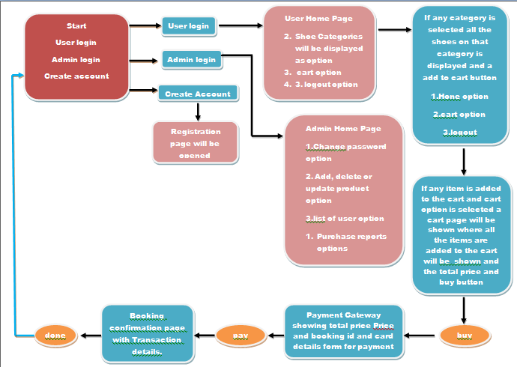

1. Home Page

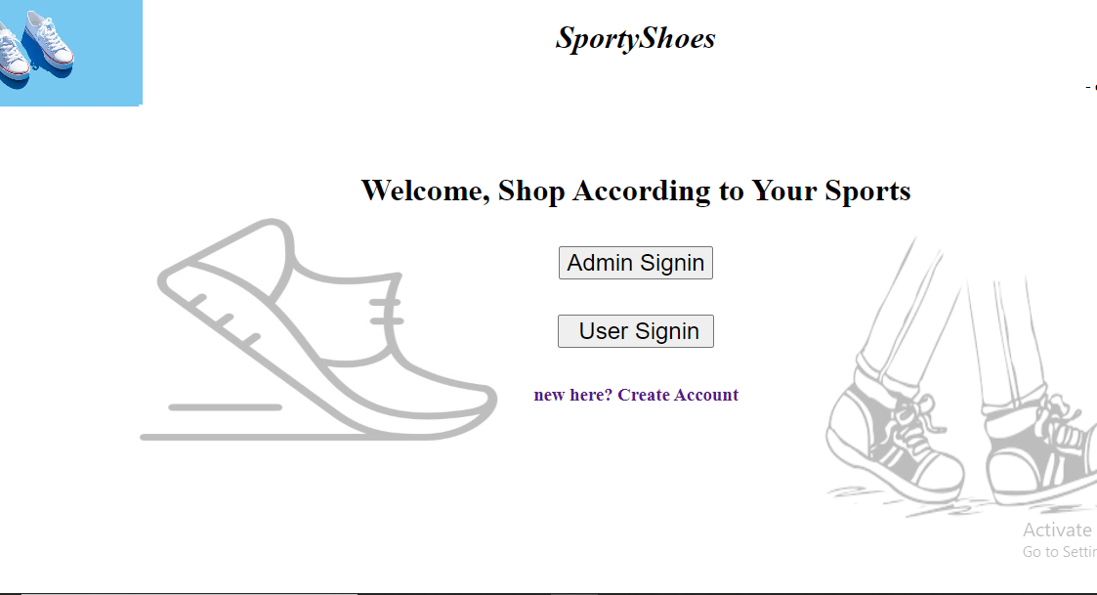

1. **On clicking create account user registration form will open.**

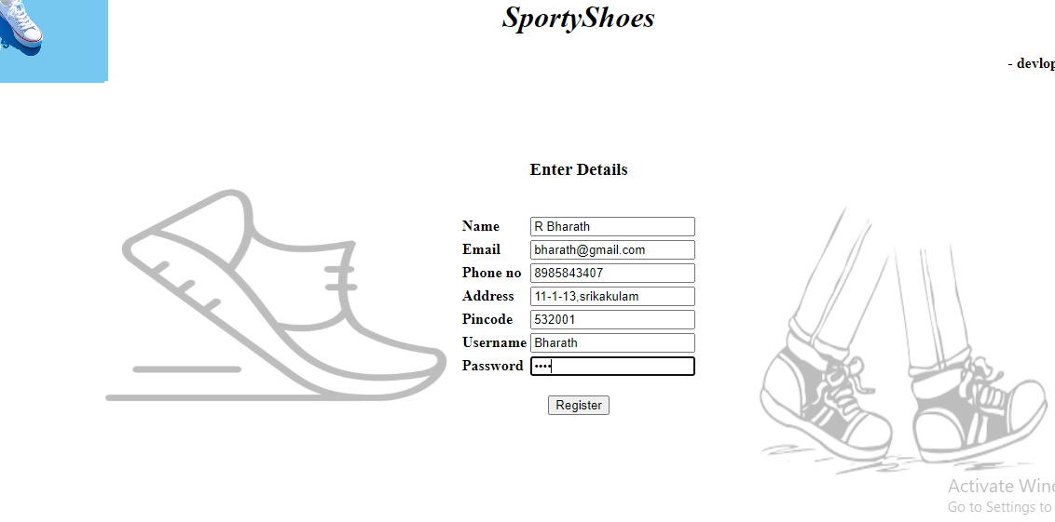

1. **It shows confirm page as updated successfully.**

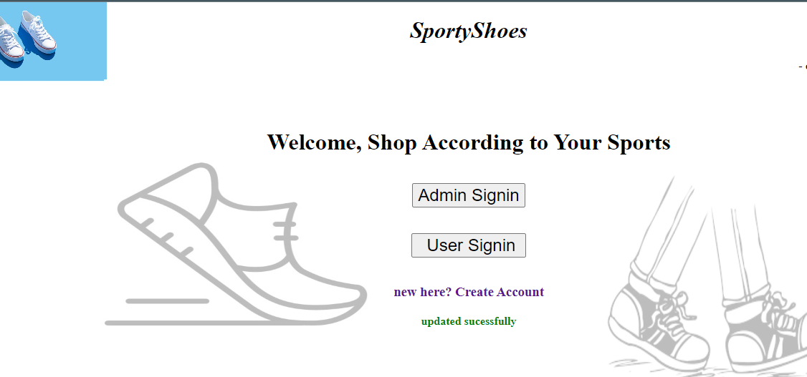

1. **In database Mysql password has been changed**

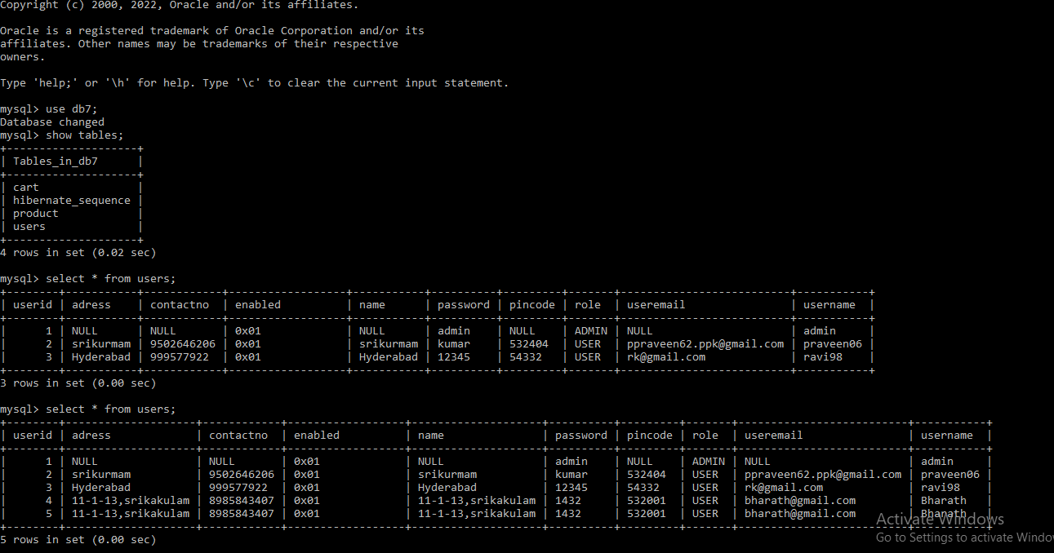

**5.Trying signin again with changed password.**

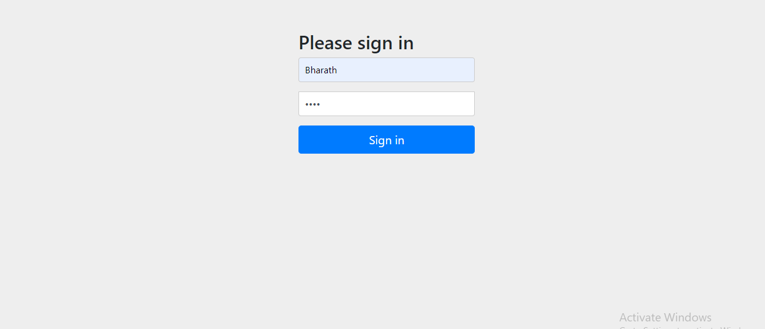

**6.Admin home page is opened.**

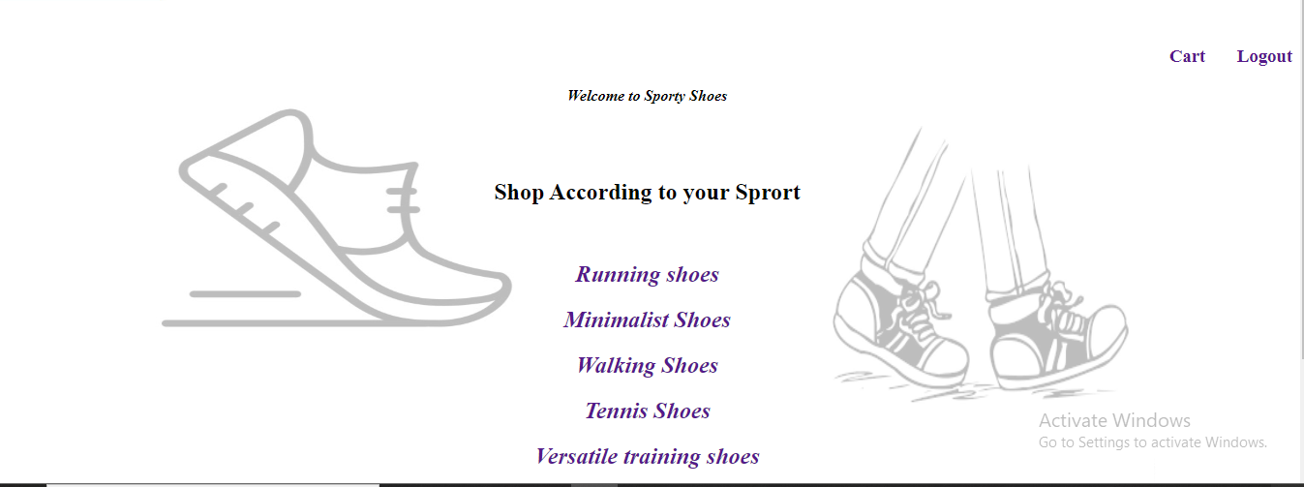

**7.clicked on running shoes all the running shoes are displayed, selected shoes are added to the cart**

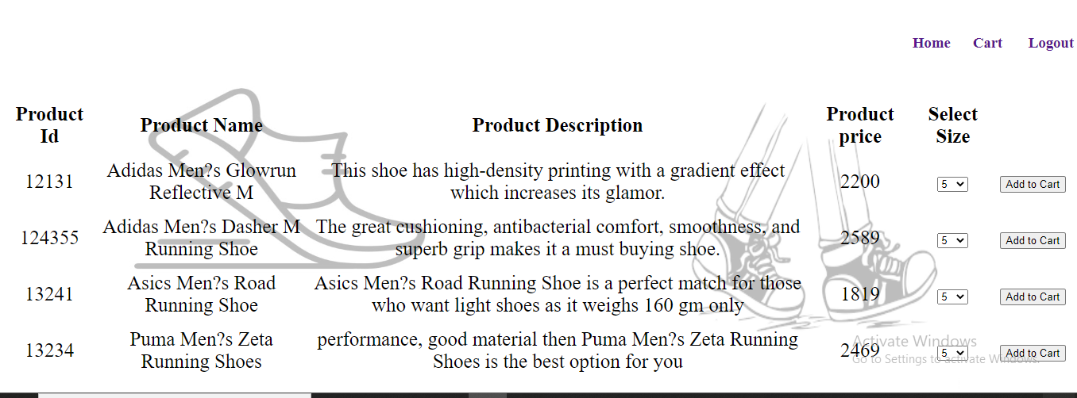

**8.if clicked and added to cart ,it displays confirmation of adding**

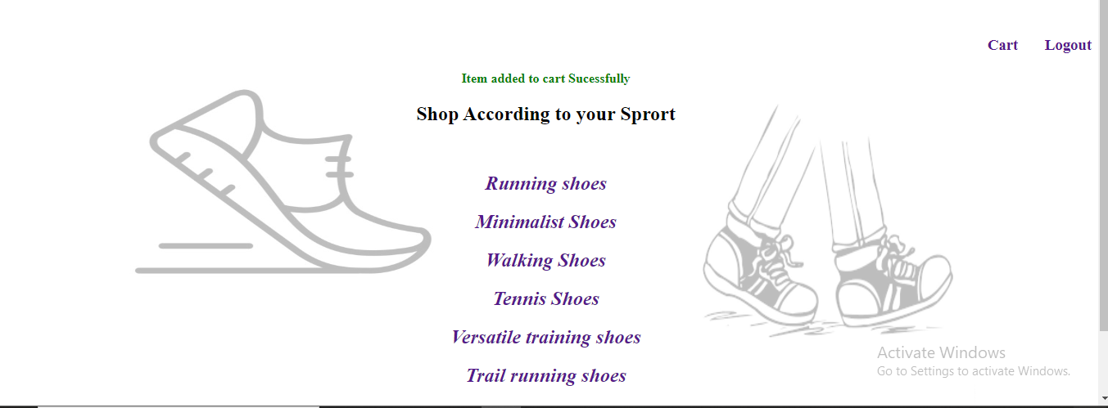

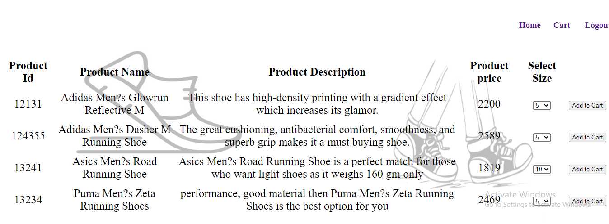

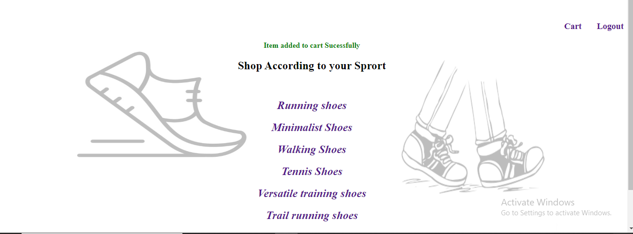

**9.Clicking on cart**

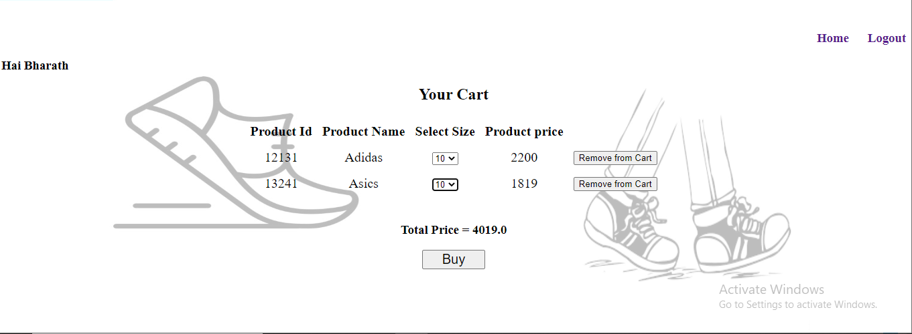

**10.removed a item ,using remove from cart button**

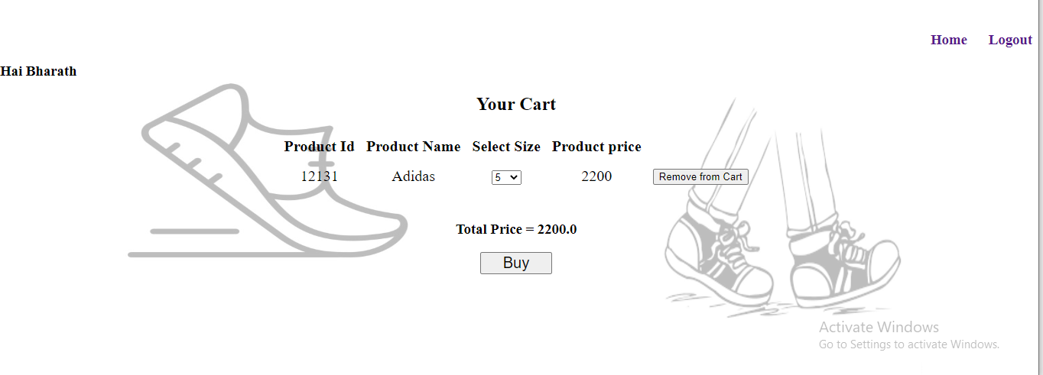

**11. on clicking buy option ,payment page will be displayed**

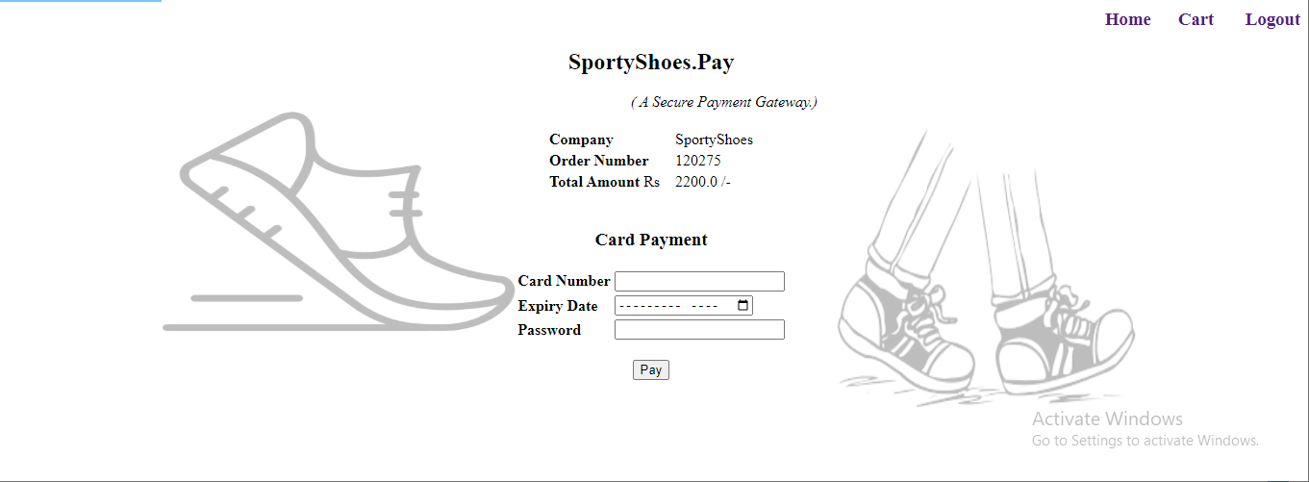

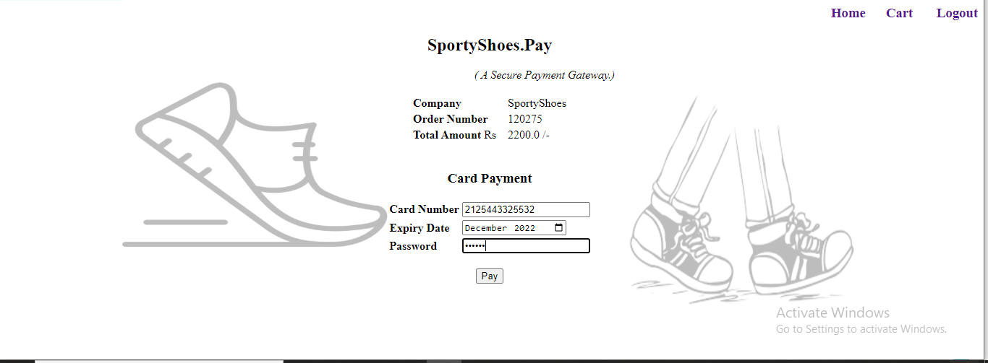

**12. On giving details and clicking on pay, successful transaction page will be shown**

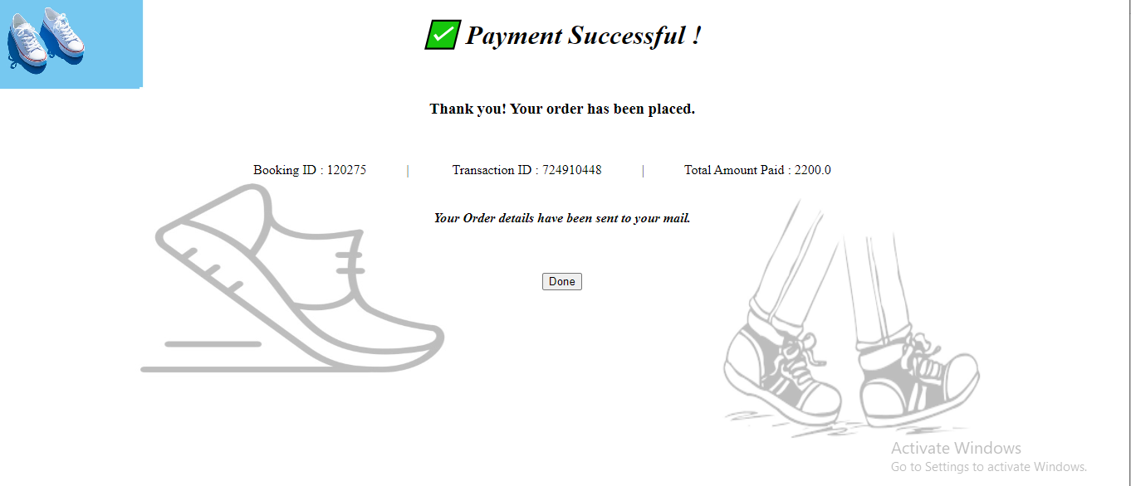

**13.Lets check admin part ,**

**Use username-admin**

**Password-admin**

**As it was updated on database by me.**

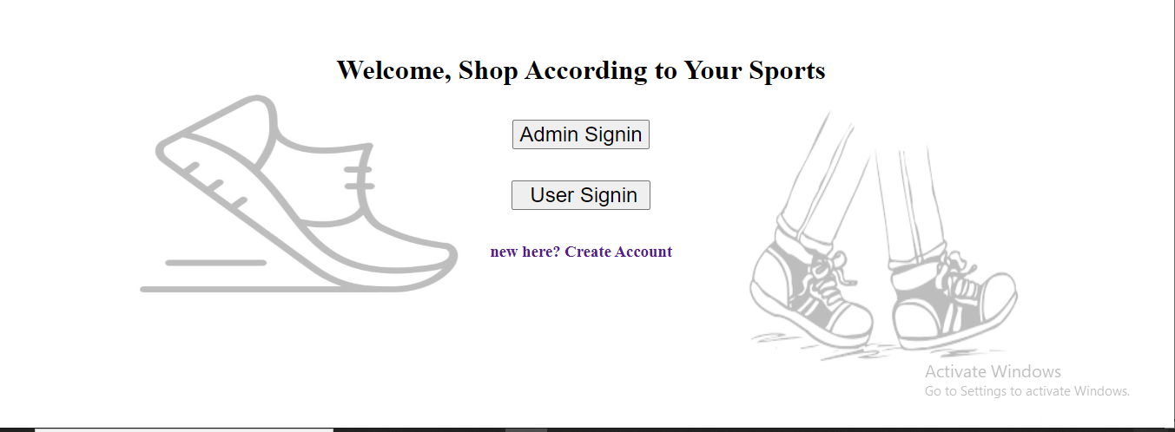

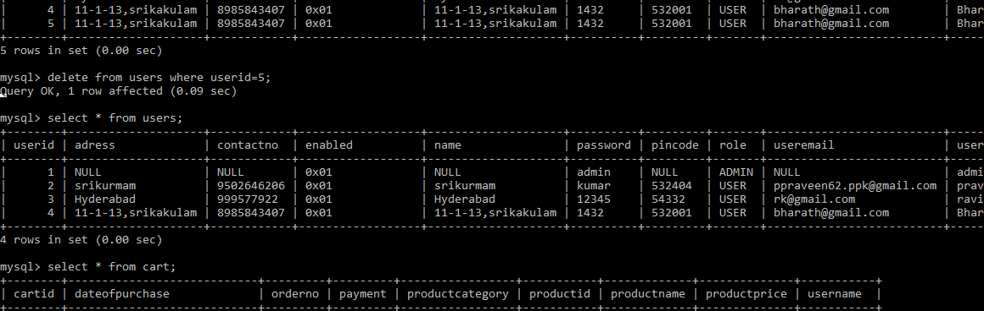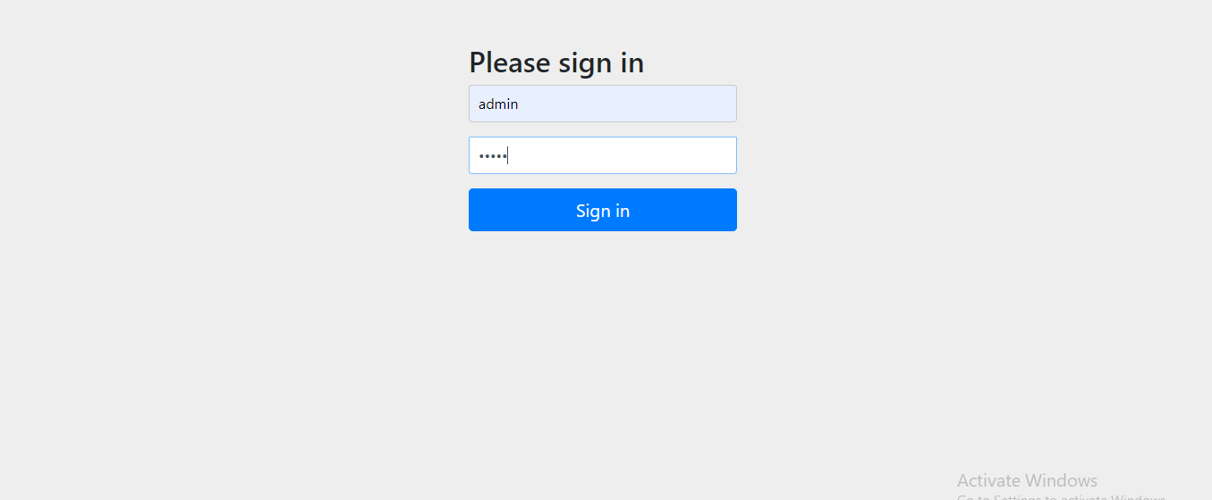

**14.On successful signin admin home page will be displayed.**

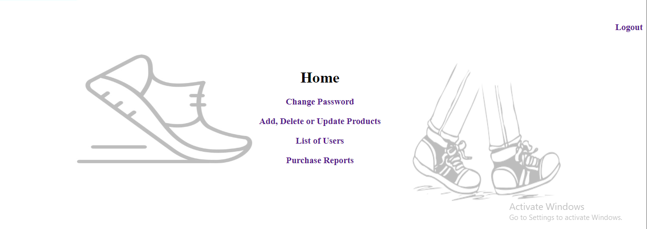

**15. on clicking change password page will be displayed and new password is given**

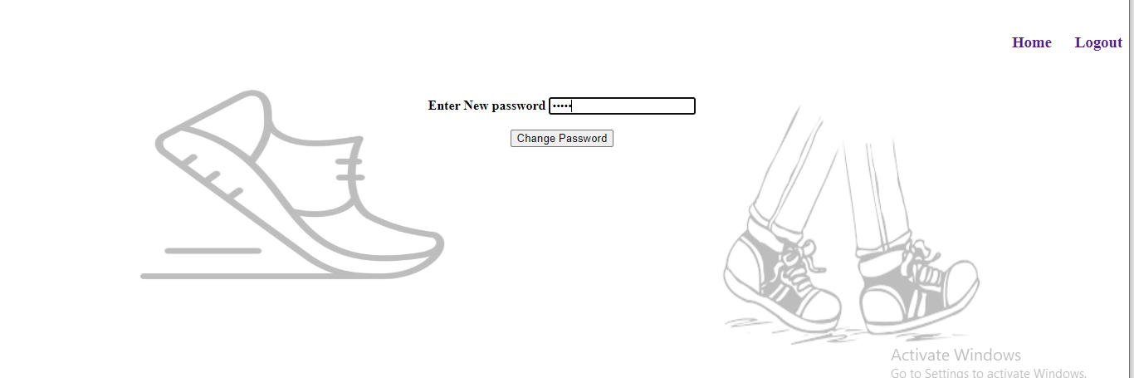

**16. Confirmation page will be displayed as updated successfully**

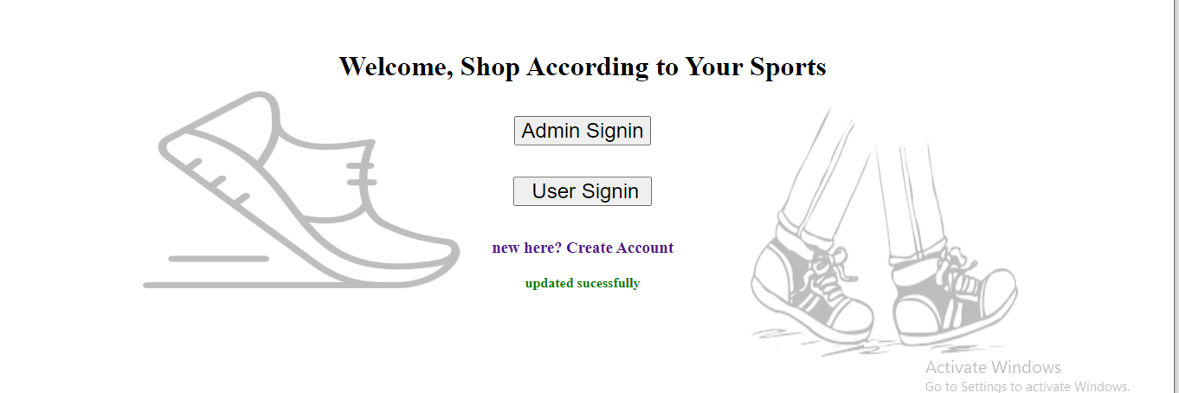

**As in database will be changed**

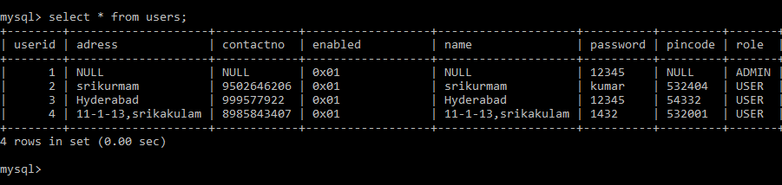

**17.particular searched username details will be displayed**

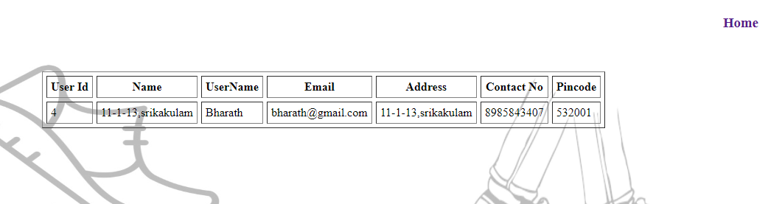

**18.coming to home page and clicking on purchase reports**

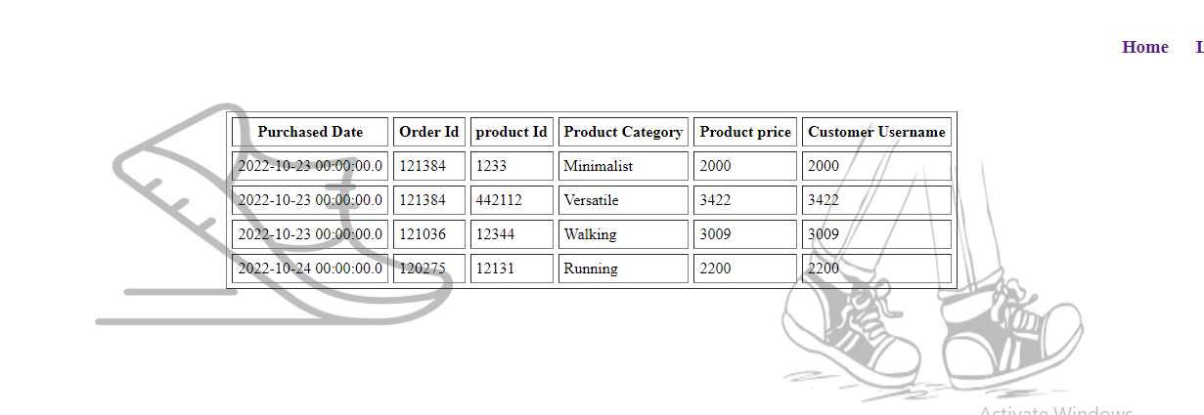

**19.on home page clicking on add ,delete or update**

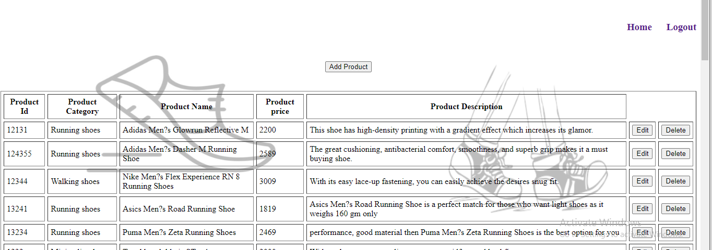

**20.on clicking on add product giving product details and giving add option**

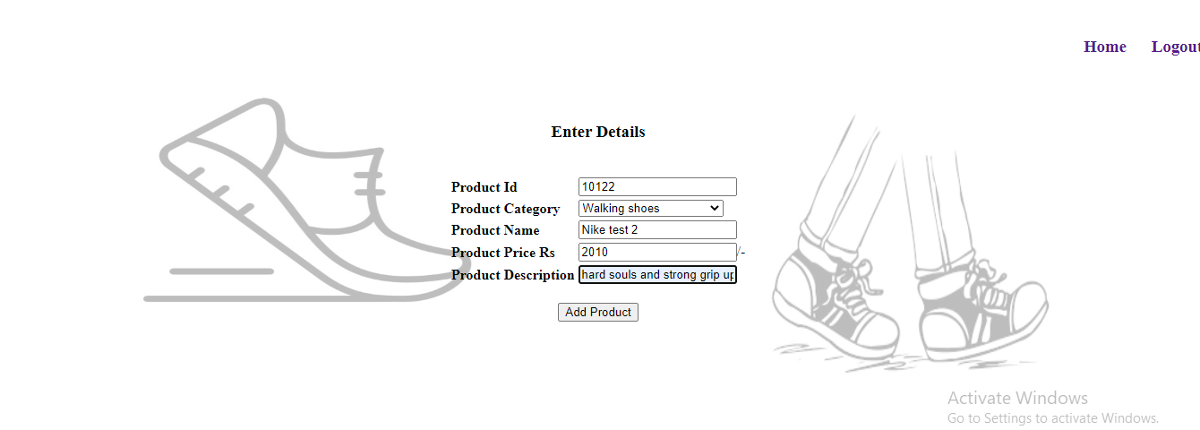

**It will be added to list**

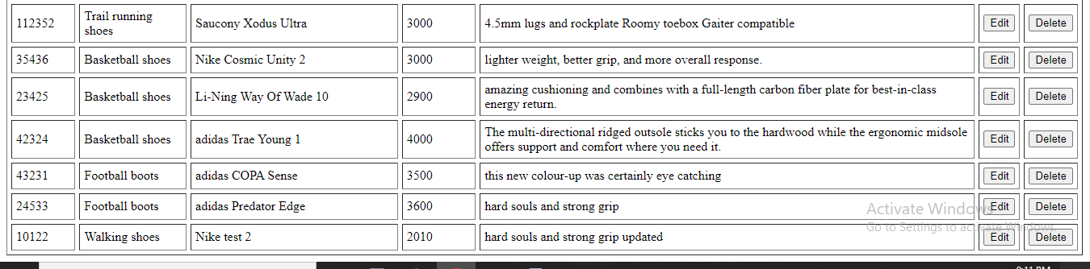

**21.on clicking edit option a update form will be opened .**

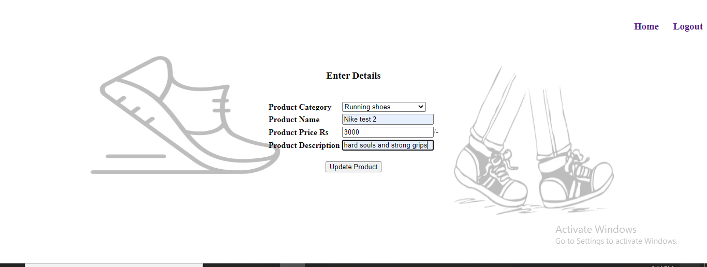

**Where I changed the price only it was updated.**

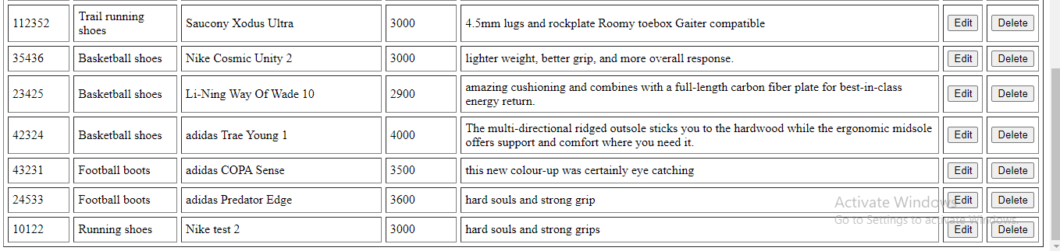

**22. then I clicked on delete button of the updated item ,it will be deleted from the list**

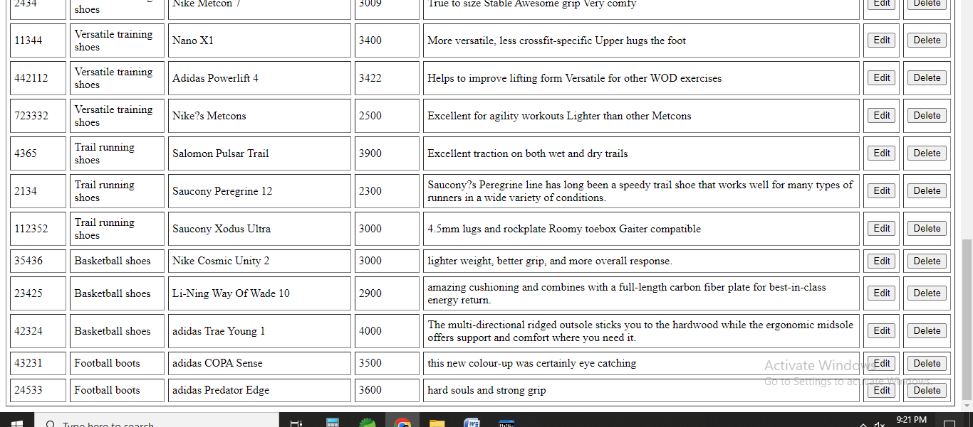

**Files**

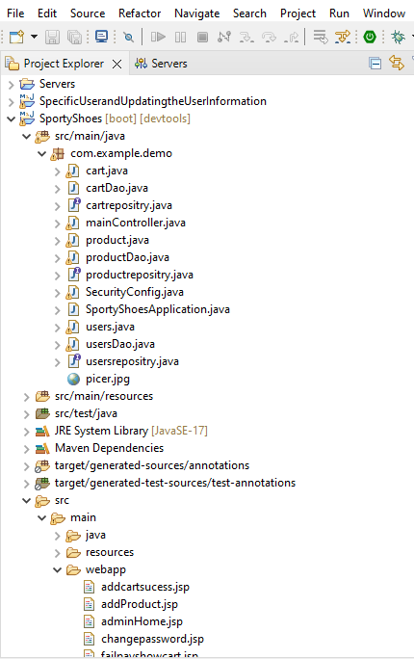

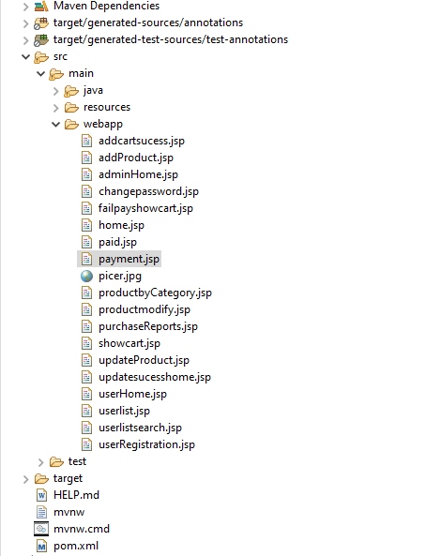

**List of core concept used:**

Spring Boot , Spring Security, Java , Jsp, Jpa, Jdbc, Hibernate, MySQL database, Collections, and sorting techniques .

**Links to the GitHub repository to verify the project completion**

[**https://github.com/Svsai97/SportyShoes_Project3.git**](https://github.com/Svsai97/SportyShoes_Project3.git)

**Conclusion:**

The E-commerce Website for Sporty Shoes is prepared according to the **provided flow and features of the websites and everything followed according to the instructions.**